
Student Name :_____________________

Short Exam related to Calibration Process – Computer Vision 2024

1 h – No document allowed. Al questions are independent (4 questions for 11 points. with 10 points you’ll get 20/20)

Question 1 (3 points – 10 mn): Let us consider the following stereo camera system. Let us assume: - that we have seven cones in the scene; - that we don’t know the 3D coordinates of each point on the top of these cones and - that we know the corresponding points in the left and right views. Let us also assume: - that we know the distance T between the optical centers of the two cameras; - that the focal of the two cameras is the same; - that the scaling parameters along the image directions are the same, and - that there is no skew for each camera. Can we recover the extrinsic and intrinsic calibration parameters of this stereo setup from these seven points only? Justify your answer.
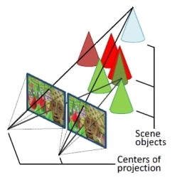


T

(a) Middlebury stereo image “cones” (b) left view

Ans:
- Seven unknown parameters (Xi, Yi, Zi, with i varying from 1 to 7)
- Seven pairs of corresponding projected points (x^{l}i, y^{l}i and (x^{r}i, y^{r}i with i varying from 1 to 7)
- Assuming that the left camera frame corresponds to the world camera frame, then x^{l} = K^{l} [I | O] X and x^{r} = K^{r} [I | T] X. We have therefore only 1 extrinsic parameter (known).

f sx 0 o^{l}x f sx 0 o^{r}x
- K^{l} = 0 f sy o^{l}y K^{l} = 0 f sy o^{r}y We have therefore only 7 intrinsic parameters
0 0 1 0 0 1

With 4 equations per corresponding points (2 for the left image + 2 for the right image) we have 28 equations (4 * 7 cones) for a total of 21 (3 coord *7 cones) + 7 unknowns to recover, therefore with a SVD approach we can solve such problem.

Question 2 (1 point – 5 mn): Can we state that the pinhole model is linear ? Hint: write the corresponding equations using cartesian coordinates, next homogeneous coordinates.
Ans: (see slide 47 of lecture 3a)

as x = f X/Z and y = f Y/Z, we haven’t a linear model relying (x, y) to (X, Y, Z)

but with homogeneous coordinates we have:

x f 0 0 0 X
Z y = 0 f 0 0 Y
1 0 0 1 0 Z
1
Which correspond to a linear model, see more explanations in https://web.stanford.edu/class/cs231a/course_notes/01-camera-models.pdf

Question 3 (3 points – 10 mn): Let us suppose that two images, I and I′, are captured by two cameras with internal calibration matrices K and K′. The two cameras have the same camera center and are related by a pure rotation given by matrix R. What is the form of the transformation T relating the two images in terms of K, K′ and R? Hint: Start from the perspective projection equation, which has the form x = 1/z K [R t] X, where x (3-vector) and X (4-vector) are the image and scene points in homogeneous coordinates, respectively. Assume the two cameras have the same camera center at the origin t1 = t2 = 0.

ANS:

I’
- O

I
both images I and I’ are at the same distance, so t1=t2. If we assume that t1 = t2 = 0 then z = z’ and:

x = 1/z K [R1 t1] X
= 1/z K R1 X

x’ = 1/z’ K’ [R2 t2] X
= 1/z K’ R2 X

Considering that x’ = T x

Then we have 1/z K’ R2 X = T (1/z K R1 X)
K’ R2 X = T K R1 X

Assuming that there is a R rotation between I and I around the same camera center’, then
R2 = R R1 and

K’ R R1 X = T K R1 X

This works with :

T = K’ R K⁻¹

Remind K⁻¹ K = Id

Question 4 (4 points – 20 mn): Lest us assume that two cameras are looking at the same scene. Their projection matrices are defined as below:

1 0 0 0
P⁽¹⁾ = 0 1 0 0
0 0 1 0

0.8 0 0.6 −4
and P⁽²⁾ = 0 1 0 0
−0.6 0 0.8 3

A 3D world point is project in the first image at the location (2, 0), and in the second image at location (−18, 0) (Each tuple is the (x,y) coordinates). What is the 3D location of this world point?

ANS:
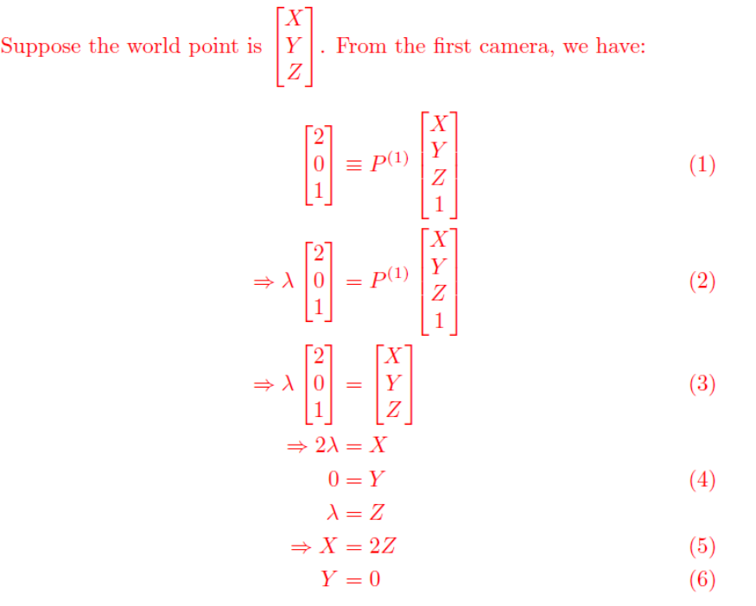

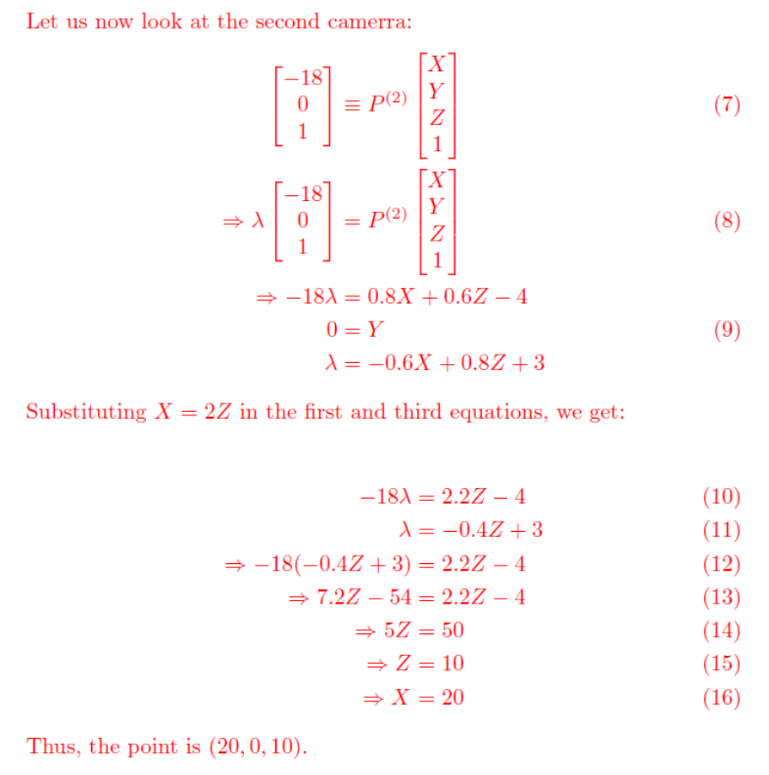

In the exam we assumed that these coordinates are known.
Such transformation is name an homography.

